RDS

1. Create RDS batabase (MySql), with the following   
   Select the free Tier template  
   Provide username and password  
   provide public access  
   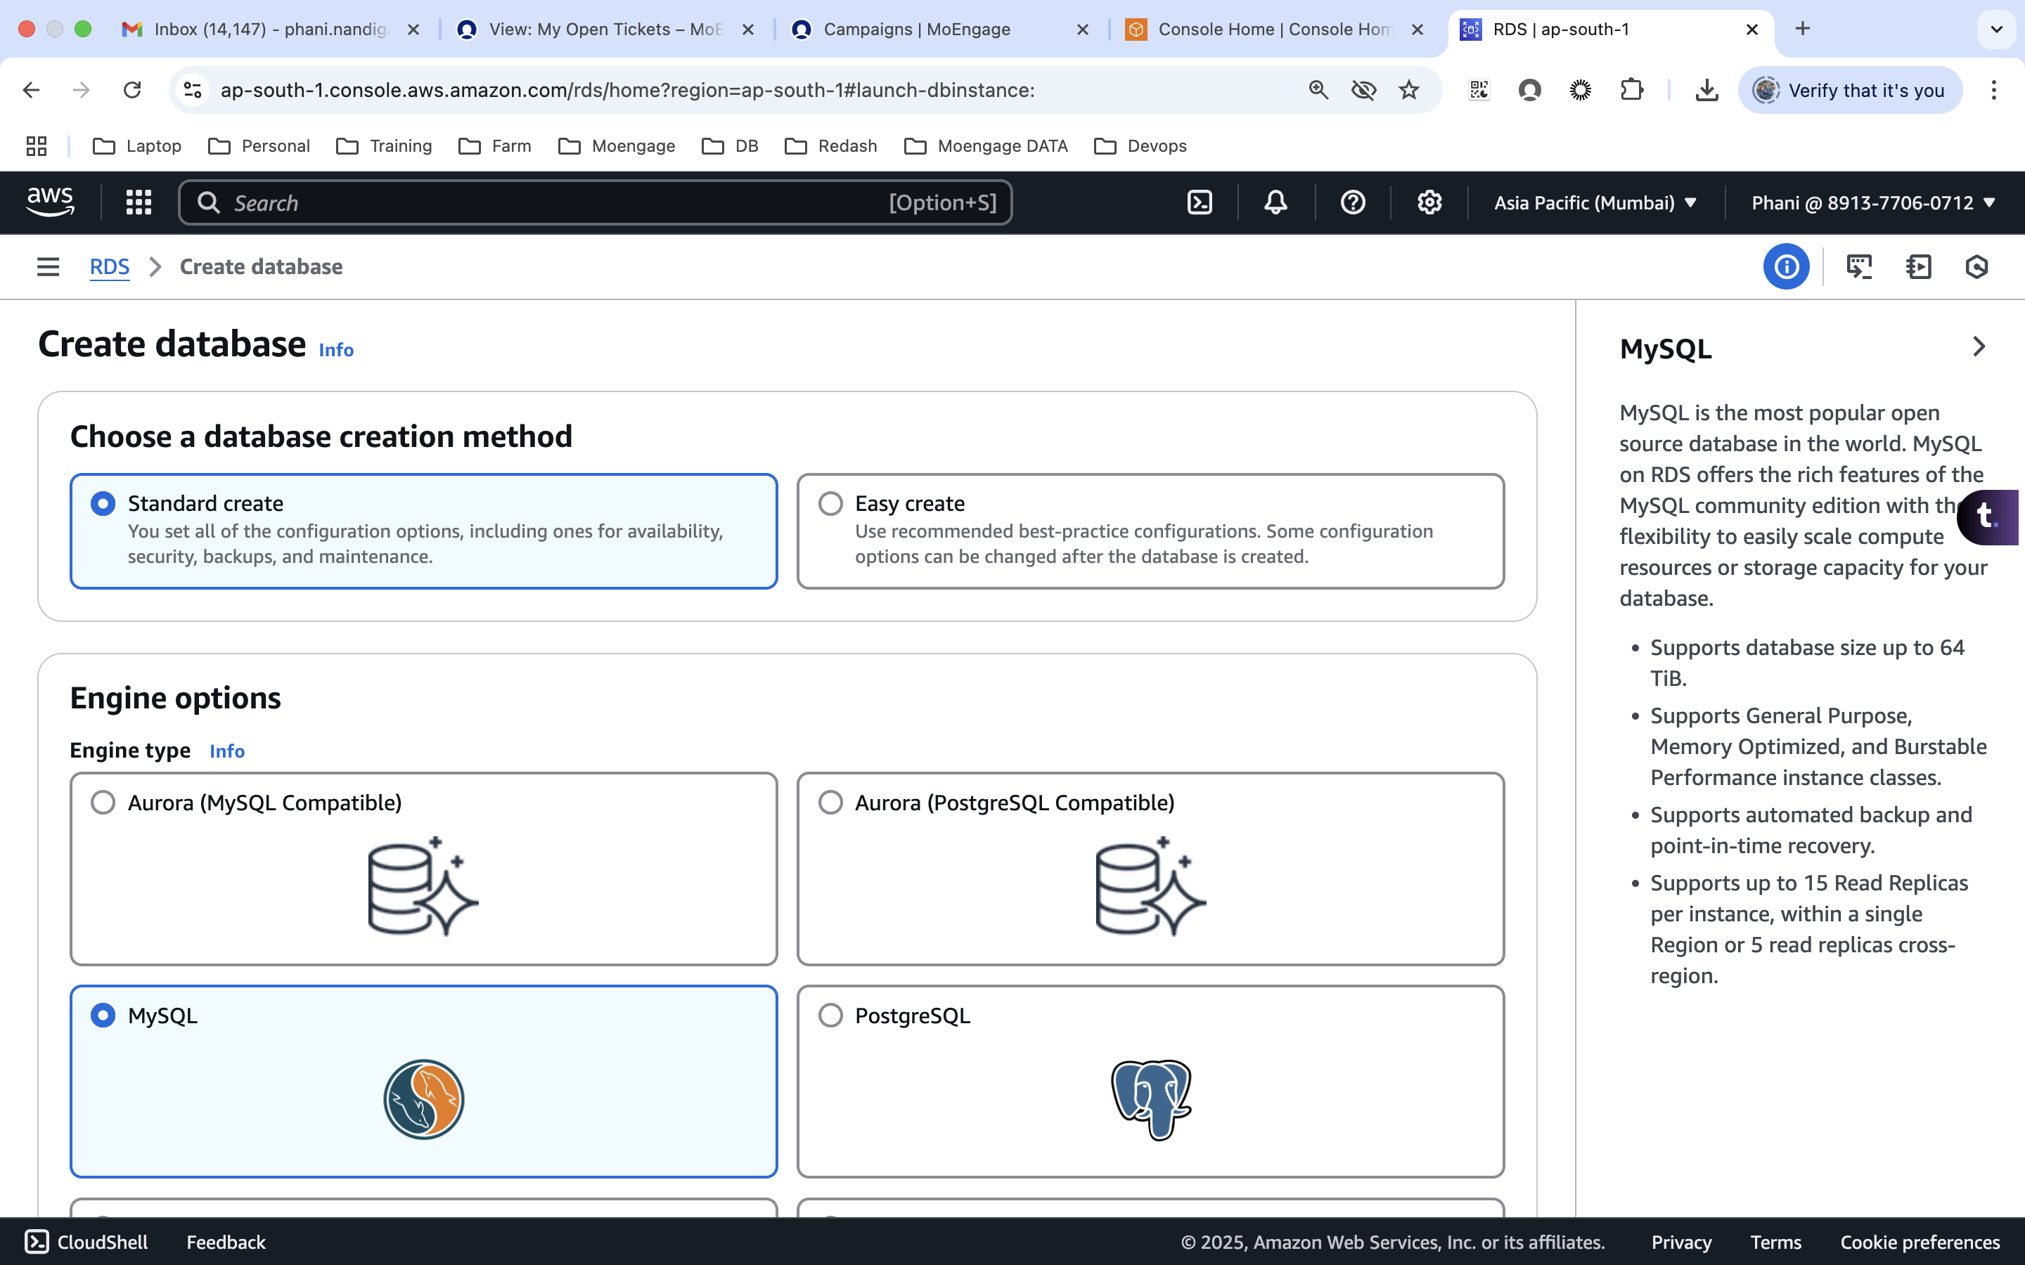
2. Created the RDS in ap-south-1a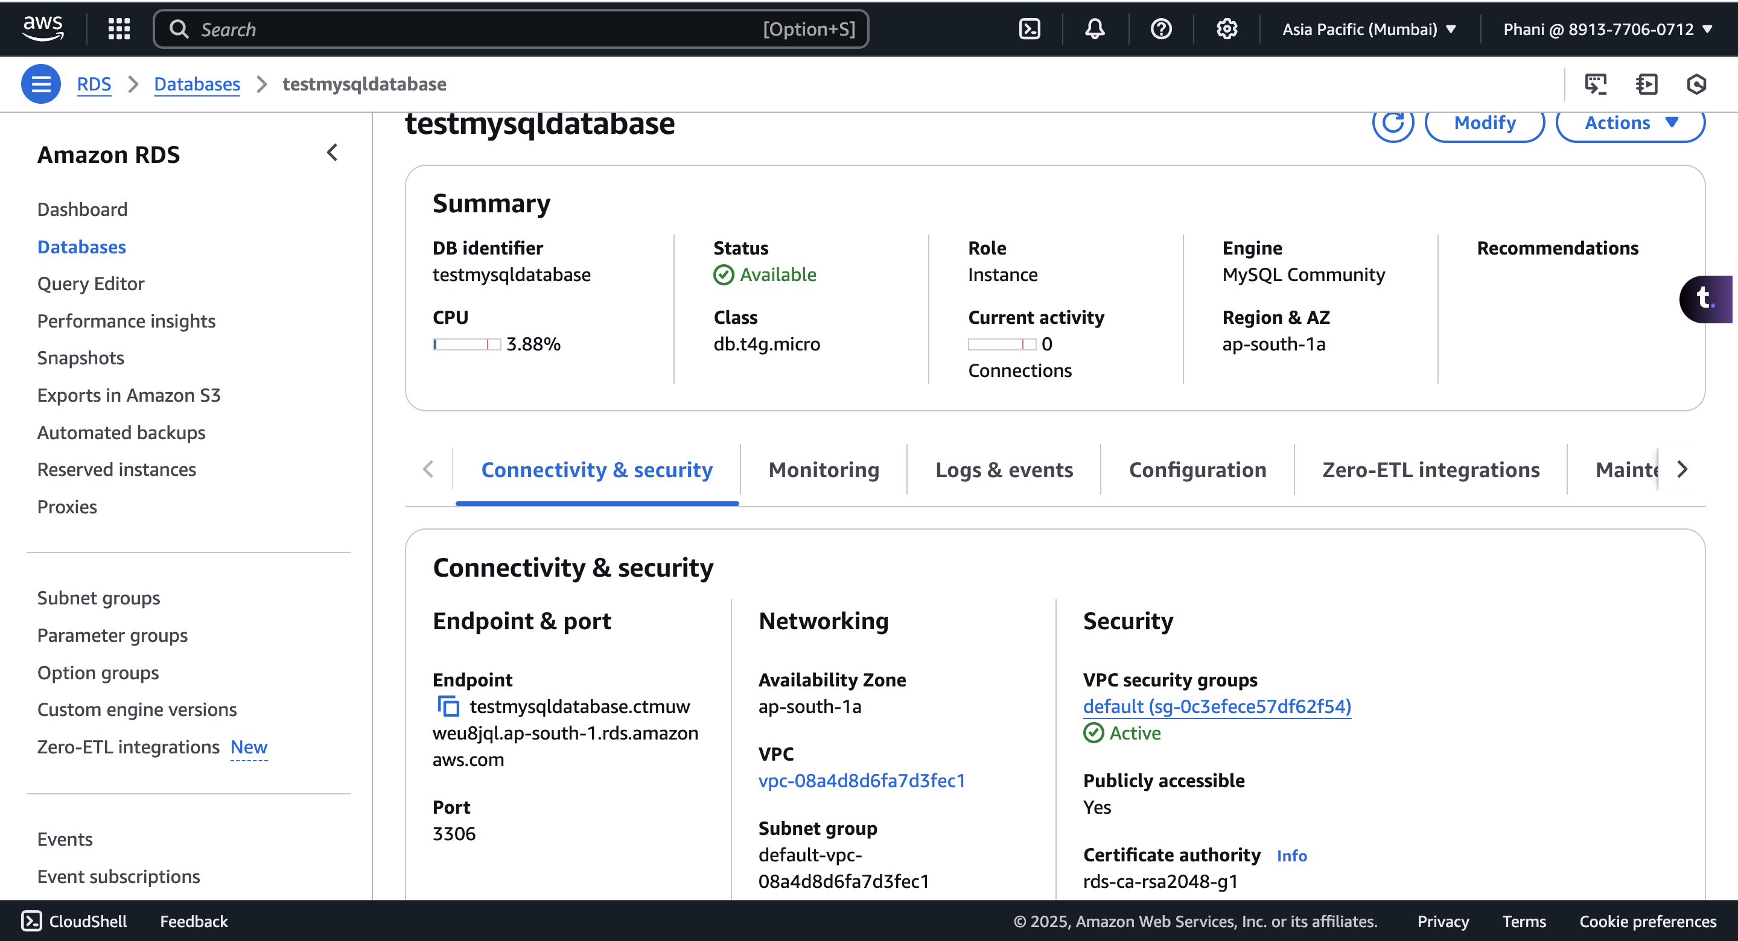
3. Create the EC2 in the same AZ or different AZ, we can access the RDS from any AZ  
   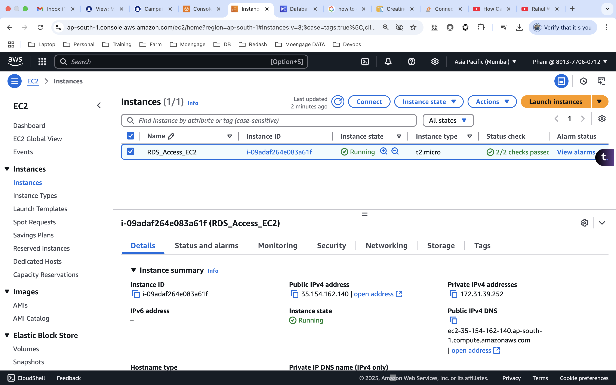  
   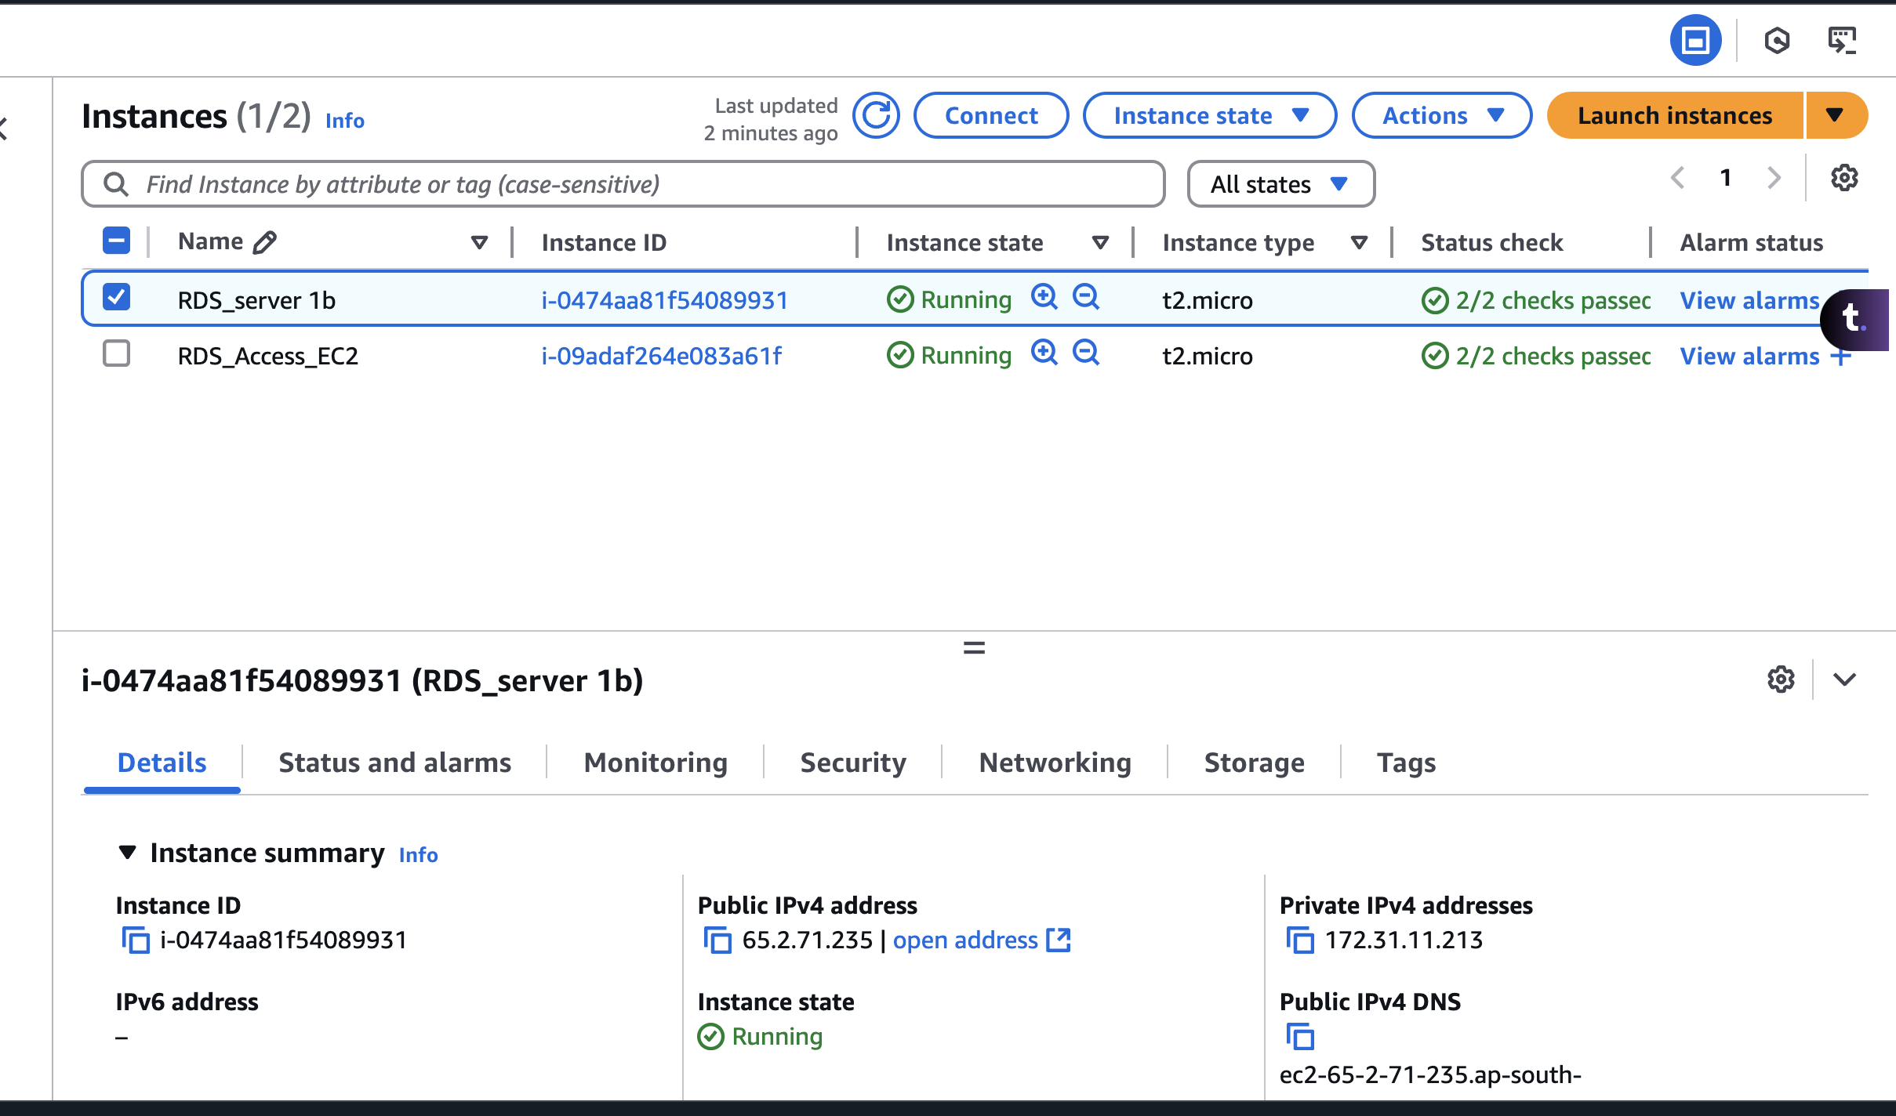
4. Install Maria db server, which is used to access the RDS  
   sudo apt install mariadb-server or sudo apt install mariadb-client-core  
   sudo systemctl status mariadb
5. Use the following command to connect to the MySql  
   mysql -h <hostname/endpoint> -P <port_number> -u <username> -p  
   **mysql -h testmysqldatabase.ctmuwweu8jql.ap-south-1.rds.amazonaws.com -P 3306 -u admin -p**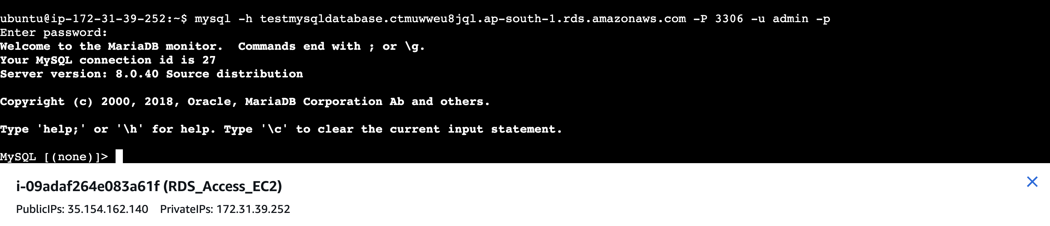
6. Create the database, table, insert the data and fetch the data.
   1. CREATE DATABASE RDS_Assignment;
   2. show databases;
   3. use RDS_Assignment;
   4. CREATE TABLE student ( sid INT AUTO_INCREMENT PRIMARY KEY, name VARCHAR(50) NOT NULL, department VARCHAR(50), number VARCHAR(14));
   5. show tables;
   6. INSERT INTO student (name, department, number) VALUES ('Phani', 'CS', '9964437999'), ('Anil', 'Civil', '9964437888'), ('Venu', 'Mechanical', '9974435678');
   7. select * from student;
   8. select * from student where department='CS';
   9. exit  
        
      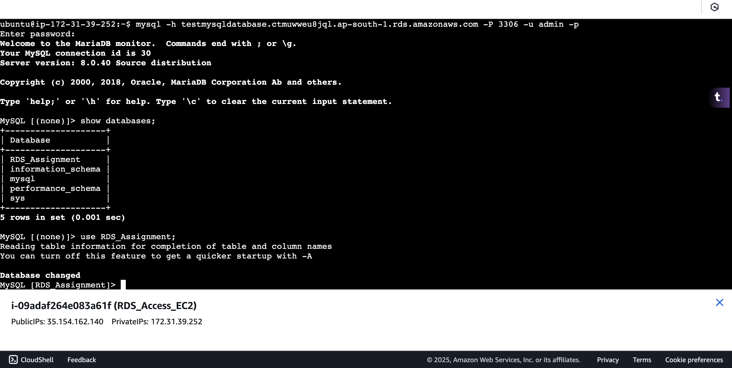  
        
      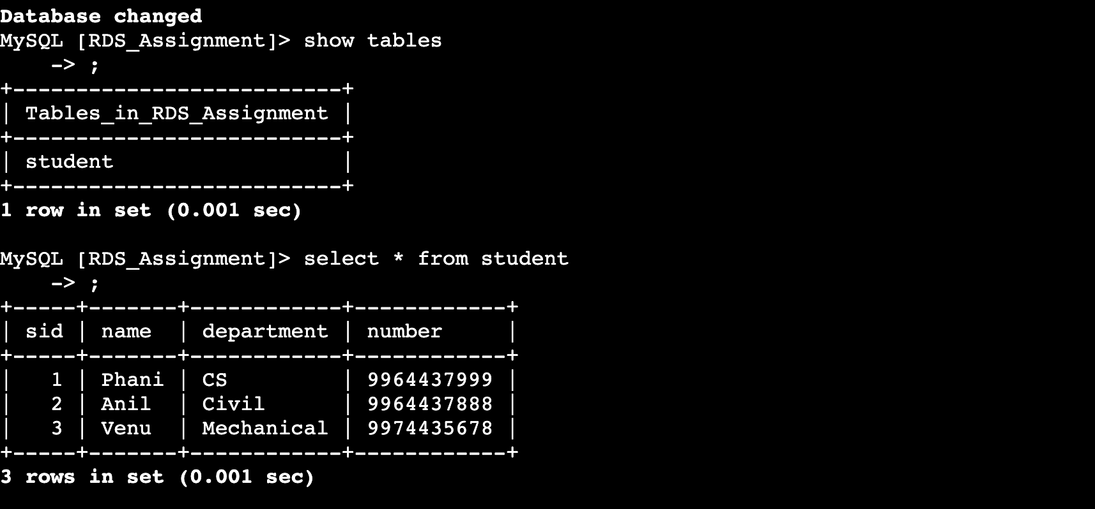

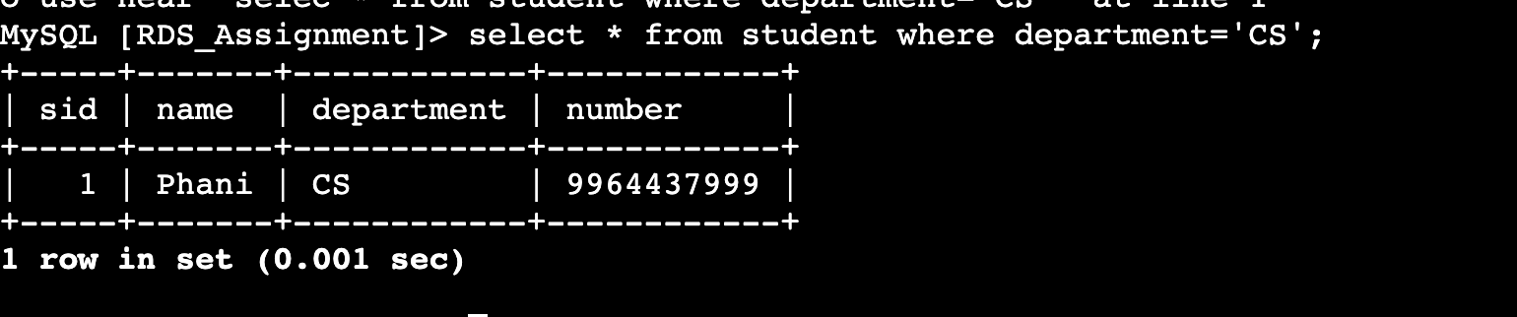

* We can take the snapshot of the RDS

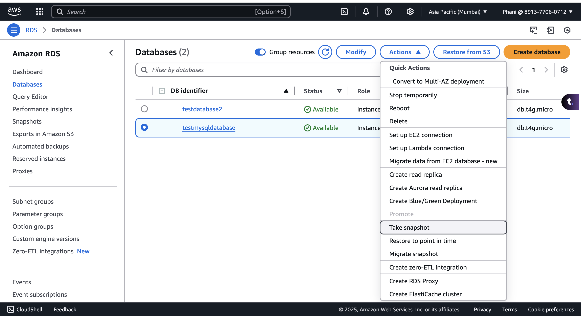

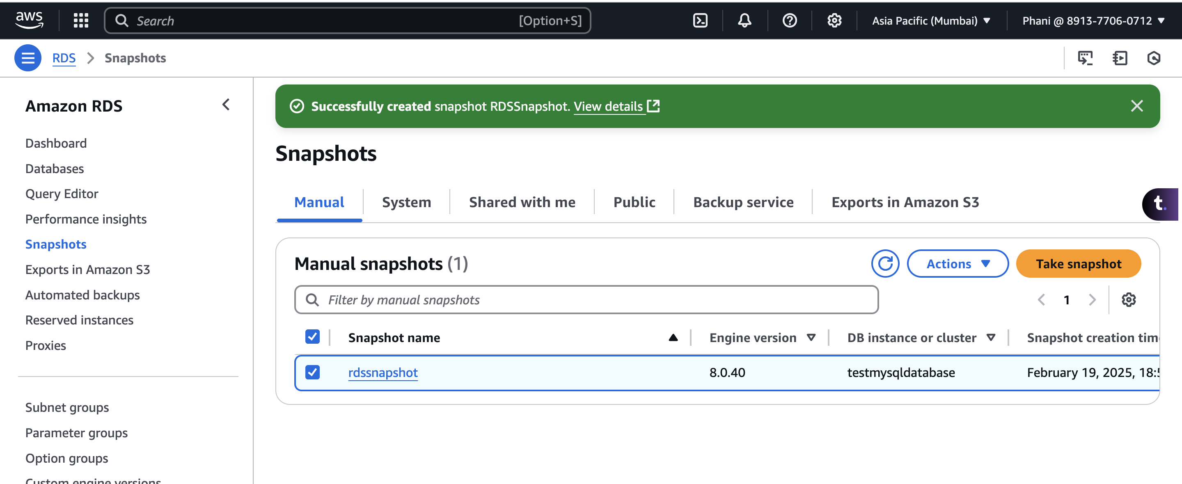

* we can share the snapshots to different accounts, copy it to different regions  
  A screenshot of a computer

  AI-generated content may be incorrect.

